Practice Placement Student Information Form

This information will be used in planning your practice placements.
Please note that the Faculty delivers a range of programmes, each with its own requirements. Please ensure that you return this as soon as possible to Placements.FHS@soton.ac.uk

Your Name | Enter Name | Date of Birth | DD | MM | YYYY
Programme | Enter Programme | Student Number | Student Num
Field
Home Address | Enter Home Address

Will you be living at home during your programme? | Yes ☐ | No ☐
Are you able to stay at your home address for placement purposes? | Yes ☐ | No ☐
Do you have access to any other accommodation in Hampshire and the Isle of Wight? | Yes ☐ | No ☐

Enter Location Details
If yes, please provide location

Enter Term Time Address

Term Time Address

Do you hold a current FULL and CLEAN driving licence? | Yes ☐ | No ☐
Do you have access to a car for your placement? | Yes ☐ | No ☐
Are you in receipt of or accepted for, a student loan under the Student Finance England provisions. If unknown at this time please ensure you update the Placement team with the outcome. | Yes ☐ | No ☐
Are you seconded to undertake the programme? | Yes ☐ | No ☐
If yes, please provide name of seconding person, clinical area and organisation with address.
Enter Details

Do you have a declared disability or health issue? | Yes ☐ | No ☐

Have you previously/currently worked in a health/social care setting? | Yes ☐ | No ☐
If yes, please provide name of setting and organisation with address.
Enter Details

Are you, or a significant other, utilising services where you might be placed? | Yes ☐ | No ☐
If yes, please provide name of service and organisation with address.
Enter Details

Do you have a personal relationship with any Mentor/Practice Educator in an area where you may be placed? | Yes ☐ | No ☐
If yes, please provide name of practice placement and organisation where the person works.
Enter Details

Are you the main carer of a child with a disability? | Yes ☐ | No ☐
Are you the main carer of a child under the age of 16? | Yes ☐ | No ☐
Are you the main carer for a dependent relative/significant other? | Yes ☐ | No ☐

If yes, what involvement do you have?
Enter Details

IMPORTANT, Please ensure you read the information below regarding Practice Placements.
- Practice placements and experiences will take place across Hampshire & the Isle of Wight and further afield for some professions therefore you will have to travel to your placement or seek alternative accommodation for the duration of your placement.
- Students can normally expect to have some placements close to their term time address.
- Student placements are pre-planned for the duration of the programme based on the information provided on this form.
- There is limited scope to indicate your clinical base preference – please read pages 3-6.
- Your Placements will be allocated to fulfil the statutory requirements of the professional and regulatory bodies and those of the University.
- If your circumstances change during the programme you will need to complete another Practice Placement Student Information Form.
- In the event of exceptional circumstances arising during the programme which may affect your placement, you will have opportunity to apply for a Review of Allocated Placement (RAP).

I have read and understood the information on pages 3-6 explaining how the Faculty will respond to my Clinical Base Preference
Yes ☐ | No ☐

I confirm that I have read and understood the information above,

Signature |  | Date

- You will be required to complete a ‘Practice Placement Student Information Form’ annually.
- If your circumstances change in between, it is your responsibility to complete another form in a timely manner.
Clinical Base Preference

All nursing students are expected to undertake placements across Hampshire and the Isle of Wight. However, in order to improve student experience and meet student preferences as far as is possible, we ask students to inform us where they would prefer to be based for the purpose of placement allocation. We will consider this information.

Before completing this form, it is important to recognise:

- Choosing a Clinical Base Preference does not guarantee that you will undertake all of your placements within that area. It is simply the means by which we take account of your preferences.

- The way in which we take account of your clinical base preference will depend on your field of practice and which geographical area you nominate.

The appendix to this form sets out how we take account of your clinical base preference. It is essential that you read the appendix before completing the form in order to understand the implications of your decision.

My preferred clinical base for placements is: (Place X in box)

Southampton | ☐
Isle of Wight | ☐
New Forest | ☐
Basingstoke, Andover and Winchester | ☐
Portsmouth | ☐

Appendix: How we take account of your clinical base preference

The practice placements which you undertake are arranged to meet the needs of your programme and to ensure that all students gain an appropriate breadth of practice experience. Placement allocation also has to take account of available placement capacity and the location of the services in which students undertake practice learning.

For all students, the allocation of placements will take account of:
- Your clinical base preference
- Any adjustments recommended by Occupational Health on the basis of a health condition
- Your access to transport
- Students who have children under the age of 12 or other carer responsibilities.
(Note that such students will still be expected to undertake daily travel for a full range of shifts, but would not be allocated placements which require them to arrange temporary accommodation)

The way in which we are able to take account of your clinical base preference will depend on the field of nursing which you are studying.

For CHILD and MENTAL HEALTH field students

Because there are a smaller number of health care services in child and mental health fields of practice, students who are studying child or mental health nursing will have to travel across the region for placements.

For child and mental health students we take account of your clinical base preference by:
- Minimising the burden of travel so far as is possible
- Seeking to ensure that no student is required to undertake significantly more travel than others.
- Avoiding repeated travel from one extreme of the region to others

For ADULT field students

The majority of students live within the Southampton area, but we have placements across Hampshire and the Isle of Wight. This means that adult field students who choose Southampton as their preferred clinical base will need to undertake significant travel for some, but not all, placements. Adult field students who nominate a preferred clinical base other than Southampton will have a greater number of placements within their preferred area.

Southampton as a clinical base preference (Adult field students)
Area classified as ‘Southampton’ shaded red

Adult field students who choose Southampton as their clinical base preference should expect to have at least 3 placements (out of the total of 6) within Acute Trusts, Community Trusts, and Private/ Voluntary and Independent healthcare settings that are located within the area shaded red on the map.

Other placements will be across Hampshire and the Isle of Wight within the area defined by the outer circle on the map.

Isle of Wight as a clinical base preference (Adult field students)

Adult field students who choose Isle of Wight as their clinical base preference will be required to travel to Portsmouth or Southampton for at least one placement.

As many of the remaining placements as possible will be allocated within Acute Trusts, Community Trusts, and Private/ Voluntary and Independent healthcare settings in the area circled in red on the map.

New Forest as a clinical base preference (Adult field students)

Adult field students who choose New Forest as their clinical base preference will be required to travel to Southampton for at least two placements (out of a total of 6).

As many of the remaining placements as possible will be allocated within Acute Trusts, Community Trusts, and Private/ Voluntary and Independent healthcare settings in the area circled in red on the map.

Basingstoke, Andover and Winchester as a clinical base preference (Adult field students)  Adult field students who choose Basingstoke, Andover and Winchester as their clinical base preference will have the majority of placements within Acute Trusts, Community Trusts, and Private/ Voluntary and Independent healthcare settings.  As many placements as possible will be allocated within the area circled in red on the map. | 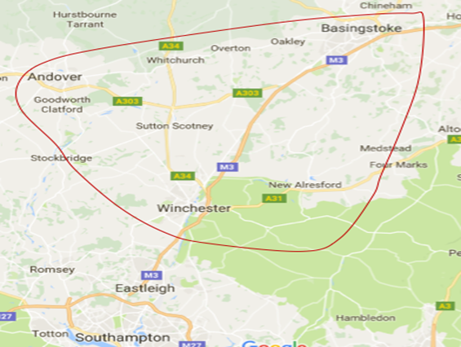
Portsmouth as a clinical base preference (Adult field students)

Adult field students who choose Portsmouth as their clinical base preference will have the majority of placements within Acute Trusts, Community Trusts, and Private/Voluntary and Independent healthcare settings.

As many placements as possible will be allocated within the area circled in red on the map.

